Faculty of Computing


Compiler Construction
Lab Tasks No # 08 Saira kousar -55503 BSCS ( Semester -6)

Task No # 01

Working:

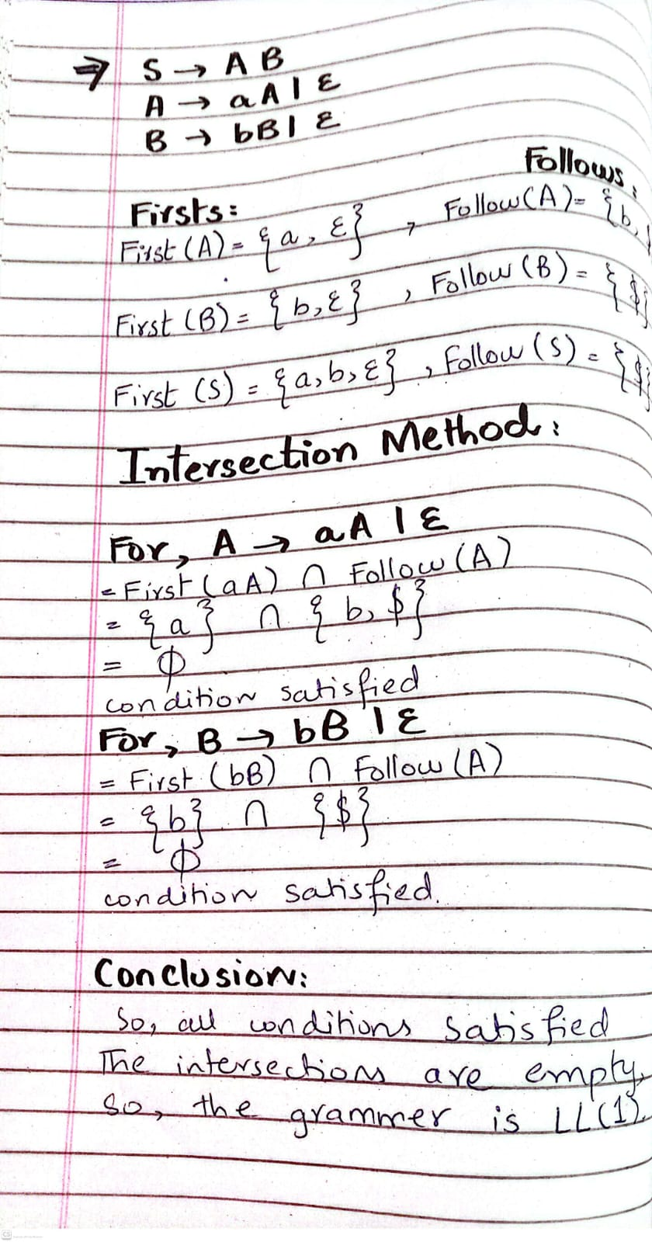

Task No # 02

Working:

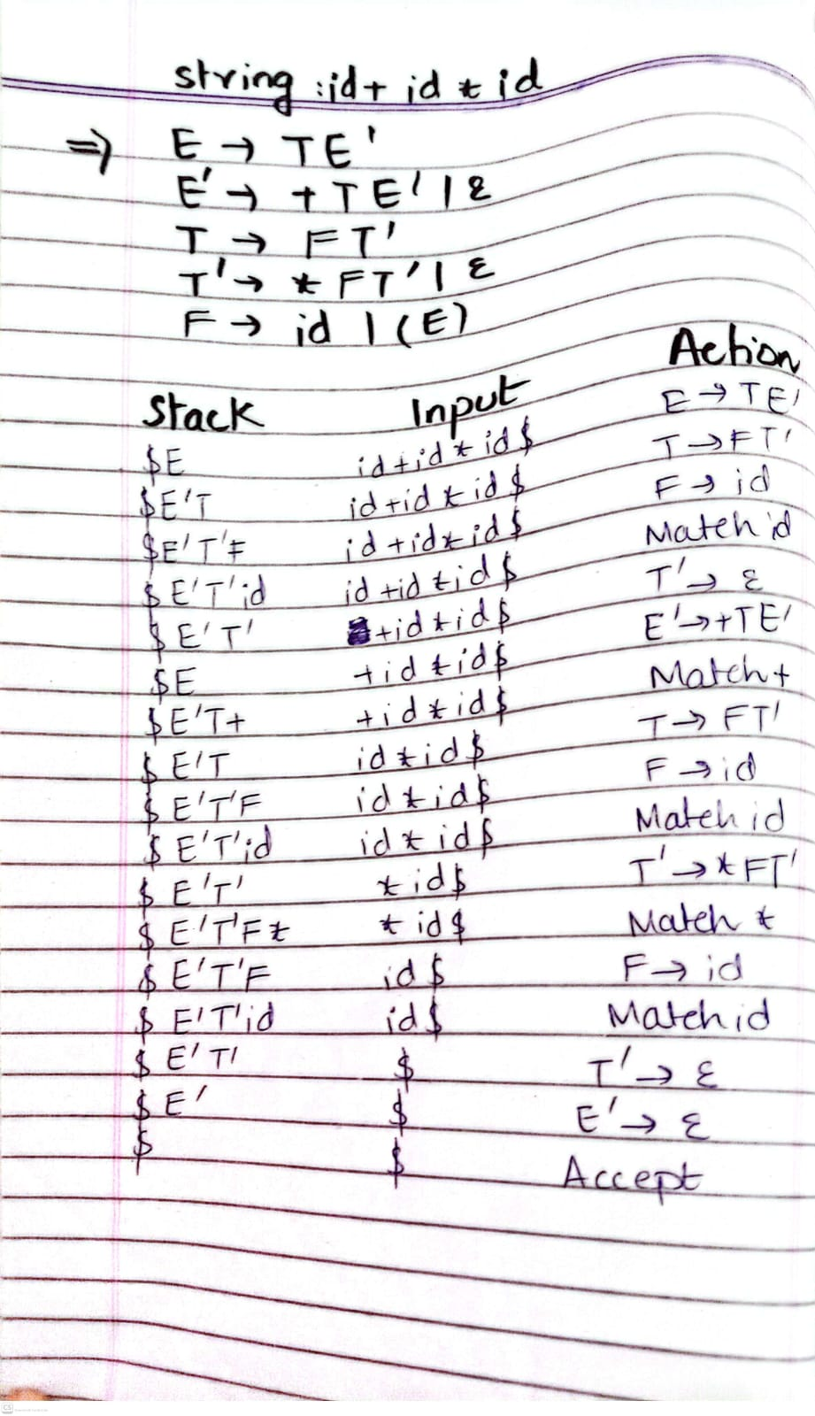

Task No # 03

Code:

#include <iostream>

#include <string>

using namespace std;

// Global input string and pointer index

string input;

int i = 0;

// Function to show error and stop program

void error()

{

cout << "String Rejected" << endl;

exit(0);

}

// Match function checks current character

// If matches, move forward (i++)

void match(char c)

{

if(input[i] == c)

{

cout << "Matched: " << c << endl;

i++; // move to next character

}

else

error();

}

// Recursive function for grammar:

// S → aSb | ε

void S()

{

// If current symbol is 'a', apply rule S → aSb

if(input[i] == 'a')

{

cout << "Apply Rule: S → aSb" << endl;

match('a'); // match 'a'

S(); // recursive call for inner S

match('b'); // match 'b'

}

// ELSE: ε production (do nothing)

else

{

cout << "Apply Rule: S → ε" << endl;

}

}

int main()

{

cout << "Enter string: ";

cin >> input;

S(); // start parsing

// If whole string is consumed → accepted

if(input[i] == '\0')

cout << "String Accepted" << endl;

else

cout << "String Rejected" << endl;

return 0;

}

Output:

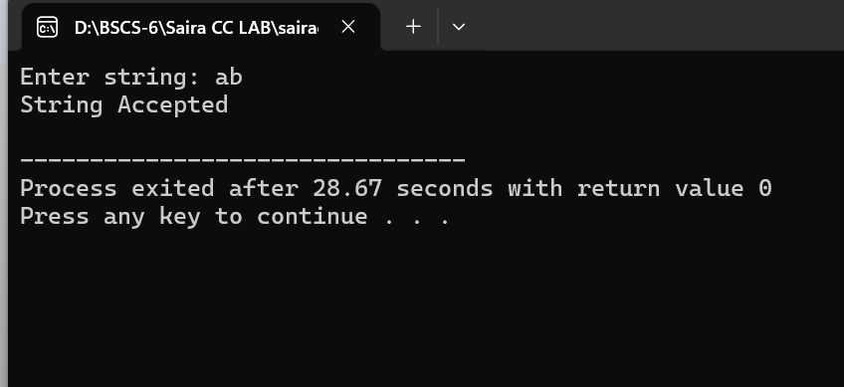

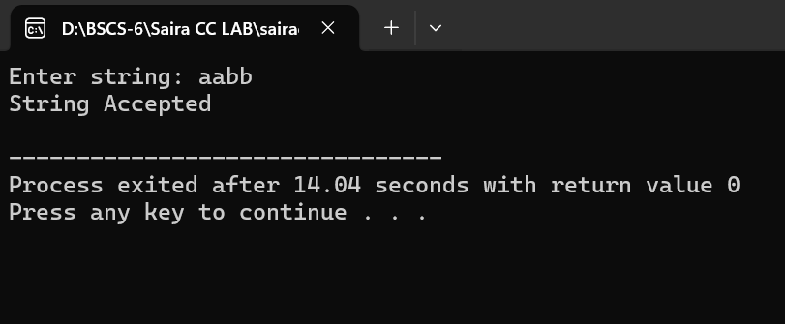

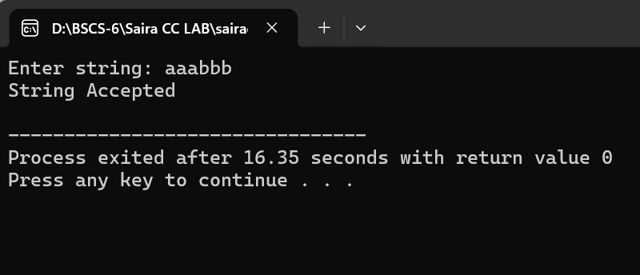

Working:

String - aabb
• S → aSb
• match(a)
• S → aSb
• match(a)
• S → ε
• match(b)
• match(b)
So string is accepted

String - ab
S → aSb
match(a)
S → ε
match(b)
So the string is accepted

String - aaabbb

S → aSb
match(a)

S → aSb
match(a)

S → aSb
match(a)

S → ε

match(b)
match(b)
match(b)

So the string is accepted.

